Swiggy Case study

**Problems –**

1. Find Customers who have never ordered.
2. Average Price/Dish.
3. Find Top restaurants in terms of number of orders for a given month.
4. Restaurants with monthly sales > x.
5. Show all orders with order details for a particular customers in a particular date range.
6. Find restaurants with max repeated customers.
7. Month over month revenue growth of Swiggy.
8. Customer’s favorite food.

**Insights –**

1. Anupama & Rishabh with user id 6 & 7 respectively are two customers who have never ordered.

**Dish** **Avg_Price**

|  |  |
| --- | --- |
| Non-veg Pizza | 450.0000 |
| Veg Pizza | 400.0000 |
| Choco Lava cake | 98.3333 |
| Chicken Wings | 230.0000 |
| Chicken Popcorn | 300.0000 |
| Rice Meal | 213.3333 |
| Roti meal | 140.0000 |
| Masala Dosa | 180.0000 |
| Rava Idli | 120.0000 |
| Schezwan Noodles | 220.0000 |
| Veg Manchurian | 180.0000 |
|  |  |
|  |  |



* In **May** month **‘Dossa Plazza’**  is the top restaurant with max orders.
* In **June** month **‘KFC’**  is the top restaurant with max orders.
* In **July** month **‘KFC’** is the top restaurant with max orders.

1. For June month there are only two restaurants ‘KFC’ & ‘Dominos’ whose sales is greater than 500.

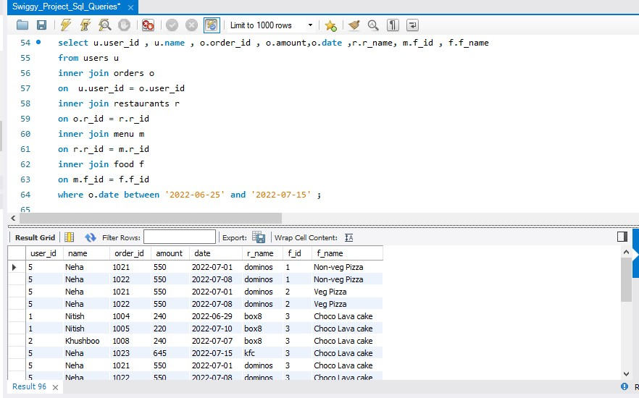

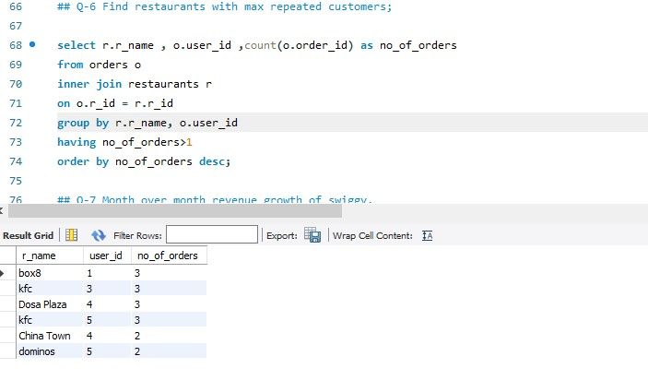

1. There is around 33% growth from month may to June & 50.46% growth from June to July.

* **Nitish** Fav food is ‘**Choco Lava Cake’** bcoz he ordered it 5 times (max times).
* **Khushboo** Fav food is **‘Rice Meal’** bcoz she ordered it 3 times (max times).
* **Vartika** Fav food is ‘**Choco Lava Cake’** bcoz she ordered it 4 times (max times).
* **Ankit** Fav food is **‘Rice Meal’** bcoz he ordered it 5 times (max times).
* **Neha** Fav food is ‘**Choco Lava Cake’** bcoz she ordered it 5 times (max times).